S.VISHNU VARDHAN REDDY(192312244)
Ex.No.4: OFDMA Resource Block Allocation Date

Objective 1 Matlab Code and Output:
clc; clear; close all;
% System parameters
bandwidth = 10e6; % 10 MHz
rb_size = 180e3; % 180 kHz per RB
% Total Resource Blocks
total_RB = floor(bandwidth / rb_size);
% Users
users = 1:6;
% RB allocation (simple equal + remainder distribution)
base = floor(total_RB / length(users));

alloc = base * ones(1,length(users));
alloc(1:mod(total_RB,length(users))) = alloc(1:mod(total_RB,length(users))) + 1;
utilization = (alloc / total_RB) * 100;
disp('Total Resource Blocks:')
disp(total_RB)
disp('RB Allocation per User:')
disp(alloc)
figure
% -------- Graph 1: RB Allocation per User --------
subplot(2,1,1)
stem(users, alloc, 'filled', 'LineWidth', 2)
title('OFDMA Resource Block Allocation per User')
xlabel('User Index')
ylabel('Number of Resource Blocks')
grid on
% -------- Graph 2: RB Utilization --------
subplot(2,1,2)
plot(users, utilization, '-o', 'LineWidth', 2)
title('OFDMA Resource Block Utilization (%)')
xlabel('User Index')
ylabel('Utilization (%)')
grid on
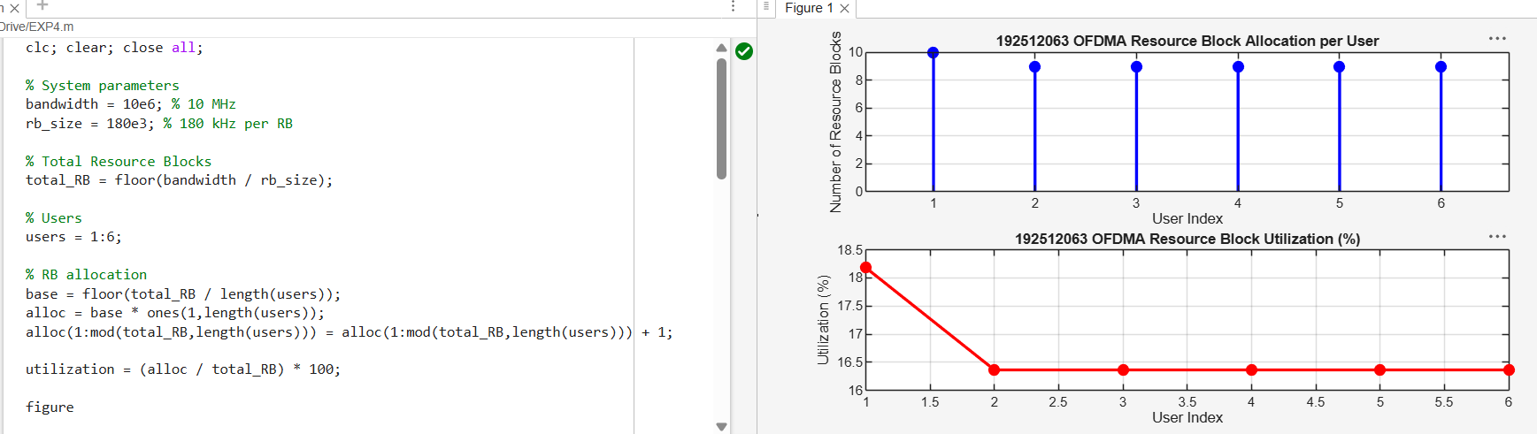
FIG.1.
Objective 2 Matlab Code and Output:
clc; clear; close all;
% Total system resource blocks
total_RB = 50;
% Number of active users
users = 1:5;
% RB allocation to users (example scenario)
alloc = [12 10 9 8 11];
% Resource Block Utilization (%)
util = (alloc / total_RB) * 100;
disp('Resource Block Utilization (%) per User:')
disp(util')
figure
% -------- Graph 1: RB Allocation --------
subplot(2,1,1)
plot(users, alloc, '-o', 'LineWidth', 2)
title('OFDMA Resource Block Allocation per User')
xlabel('User Index')
ylabel('Number of Resource Blocks')
grid on
% -------- Graph 2: Utilization (%) --------
subplot(2,1,2)
plot(users, util, '-s', 'LineWidth', 2)
title('OFDMA Resource Block Utilization (%)')
xlabel('User Index')
ylabel('Utilization (%)')
grid on
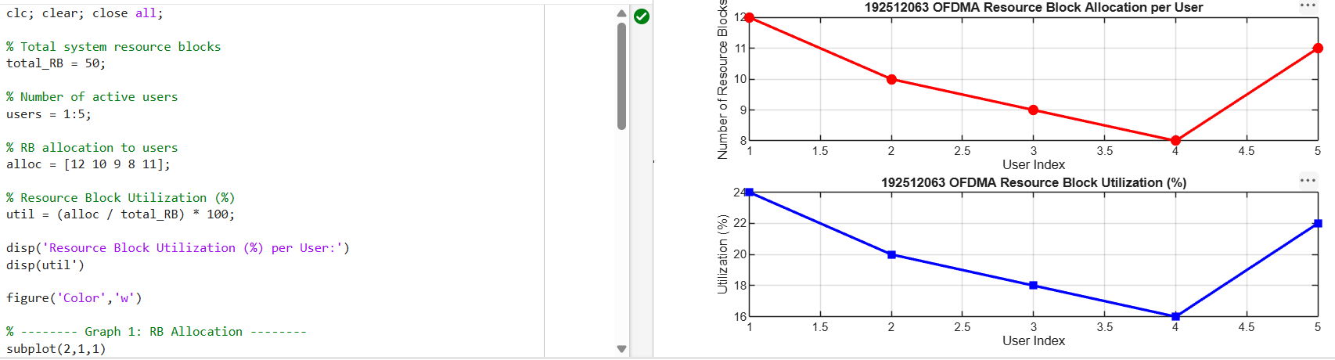

Objective 3 Matlab Code and Output:
clc; clear; close all;
% System parameters
rb_bw = 180e3; % Bandwidth per RB (180 kHz)
users = 1:5;
% Allocated Resource Blocks per user
alloc_RB = [12 10 9 8 11];
% Modulation efficiency (bits/symbol)
mod_eff = [2 4 6 4 2]; % QPSK, 16QAM, 64QAM etc.
% Throughput calculation (Mbps)
throughput = (alloc_RB .* rb_bw .* mod_eff) / 1e6;
disp('User Throughput (Mbps):')
disp(throughput')
figure
% -------- Graph 1: Throughput per User --------
subplot(2,1,1)

plot(users, throughput, '-o', 'LineWidth', 2)
title('OFDMA User Throughput')
xlabel('User Index')
ylabel('Throughput (Mbps)')
grid on
% -------- Graph 2: RB vs Throughput --------
subplot(2,1,2)
plot(alloc_RB, throughput, '-s', 'LineWidth', 2)
title('Resource Blocks vs Throughput Relationship')
xlabel('Allocated Resource Blocks')
ylabel('Throughput (Mbps)')
grid on
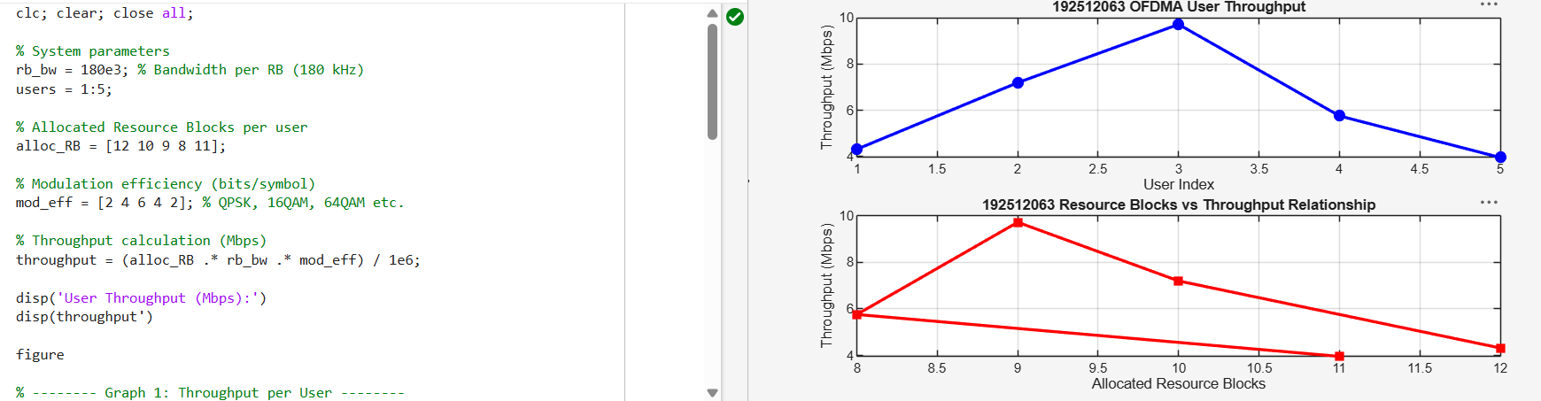
FIG.3.

